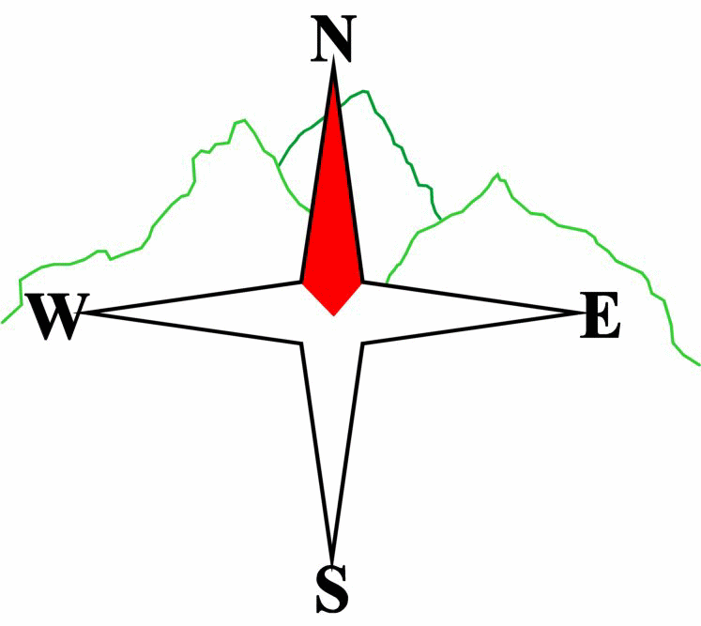***Blairgowrie & District Hillwalking Club***

**www.bdhc.org.uk**

**Ben Gulabin**

**23/11/2025**

**O.S. Map No**: 43

|  |  |  |  |  |
| --- | --- | --- | --- | --- |
| **Meeting :** | **Blairgowrie** (**Wellmeadow**): **08:00** | | **Alyth** (**Square**): **07:45** | |
| **times :** |  | | | |
| **Transport:** | **CARS** | | | |
|  | | | | |
| A Walk – Ben Gulabin via Carn Bhinnein from Cairnwell | | | | |
| Leave some cars at Spittal. Start at Cairnwell ski centre NO 138 782. Go westwards up the track towards Loch Vrotachan. From the col traverse southwards to pt 808. Follow ridge SW to Carn nan Sac 920mthen W to **Carn a’ Gheoidh** **(M 975m)**. Continue W then S to **Carn Bhinnein** **(M top 915m)** for spectacular views on a clear day. Return to lochan at pt 854 then traverse eastwards round corrie to pt 829. Follow track southwards over Carn Mor to **Ben Gulabin (C 806m)**. Descend N into Coire Shith. (The Alllt Coire Shith is the start of the Shee Water.) Turn W to pick up faint path on N of burn going down to Gleann Taitneach. Follow track S then SE back to the Spittal. | | | | |
| Approx. distance: 20 km | | Total ascent: 750 m | | Min. **walking** time: 6½ hrs |
|  | | | | |
| B Walk – Carn Ait | | | | |
| Start at the Spittal of Glenshee NO 110 698. Cross the A93 and follow the Cateran Trail to Tomb. Turn N up a track that passes east of Bad an Loin. Keep right at a junction to its NE, 124 709. Follow this N then NE to its end S of Sron na Fionnach. Climb E to summit of Carn Chom-Stri (718m). Follow ridge NNE over Carn Aig Mhala to summit of **Carn Ait (C top 864m)**. Then walk E to col at 151 732 turning S to meet the start of a track at 148 719. Follow this down to where it meets the Cateran Trail. Turn right and follow trail NW back to start. | | | | |
| Approx. distance: 18 km | | Total ascent: 730 m | | Min. **walking** time: 6 hrs |
|  | | | | |
| C Walk– Cateran Trail from Spittal to Lair | | | | |
| Start at Spittal of Glenshee NO 110 698. Follow the Cateran tail southwards until it meets the A93. Walk 200m N to the excellent *Glenshee Café and Gift Shop* at Lair (**care on dangerous road)**. The walk may be extended by walking to Loch Beanie and back from the Glenshee Lodge (head east along path at 136 683 [add 5 km, 2 hrs]) | | | | |
| Approx. distance: 11.5 km | | Total ascent: minimal | | Min. **walking** time: 4 hrs (@ 3 kph) |

|  |  |
| --- | --- |
| IMPORTANT: YOUR SAFETY IN THE HILLS | |
| **The Committee reminds members and guests of the following important points:** | |
| * You are responsible for your own safety * Club officials are not trained mountain leaders * Are you fit enough to complete your chosen walk in the available time? * Know where you are going on the walk and follow the route on your map. * Know how many are in your party and stay together | * Ensure you have enough food plus emergency rations * Carry a map & compass, survival bag, torch, whistle and small first aid kit. Know how to use them. * In winter conditions you must carry an ice axe on high level walks (club rule). You are also recommended to carry crampons. * **Learn** how to use your equipment. |
|
|
|
|
|  |
| **Club officials will be happy to give advice on any of these points if requested.** | |

The next club walk is on the **14th December- Xmas Walk** – Killiekrankie to Pitlochry starting at 08:00 (Blairgowrie) and 07:45 (Alyth). There will also be an informal **‘Twixt’ meet 27-29 December at Aviemore**

**Please note that the Minimum walking times are based on reasonably fast walkers and assuming good conditions. The times do not include stops or breaks.**

## **In poor weather conditions or if members are not comfortable walking at 4km/hour then alternative or shorter routes should be considered.**

Template revision: 2024-12-03